Title is Centered with the Bold 14 points Times or Times New Roman Font
First Author,^{1,*} Second Author,² and Third Author³
¹Affiliation, Address Vienna , Austria
²Affiliation, Address Vienna , Austria

Synopsis One page extended abstract (A4) should be submitted via e-mail to Vytautas Astasauskas astasauskas@iap.tuwien.ac.at before April 1st, 2017.

The extended abstract should contain the title (bold), names, affiliations (italic), e-mail address of the corresponding author, text, references (optional) [1-2]. When using MS-Word, use double column, 10 point Times or Times New Roman font and single spacing. You can use figures and tables, if necessary, within the total length of the abstract of one page. DO NOT provide a page number on the abstract.
Only the PDF version is acceptable. Convert your abstract to a PDF file before submission and e-mail the PDF file of your abstract to the secretary. If you have any question and comments, please contact:

Vytautas Astasauskas astasauskas@iap.tuwien.ac.at

Since conference proceedings will NOT be published for this workshop, you are encouraged to briefly describe the employed methodology and incorporate pertinent results in the form of figures or tables. In this way the book of abstracts is hoped to contain a reasonable “snapshot impression” of the field.
References
[1] A. Author and B. Author, J. Surf. Anal. 11 (2004) 99.
[2] C. Author, “Quantitative Surface Analysis”, Vienna 2004, p.99.
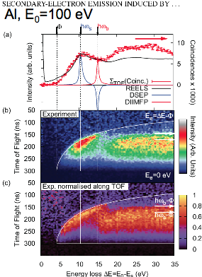
Figure 1. You are encouraged to incorporate pertinent results in the one-page camera ready abstract in the form of a figure or table.

E-mail: corresponding.author@xxx.yyy bellissimo@iap.tuwien.ac.at

